Lab Objective

Managing DNS Resource Records

**Lab Procedures**

**1.** Log in to RWDC01 as the **Contoso\administrator** user account. The Server Manager console opens.

**2.** On Server Manager, click Tools > DNS to open the DNS Manager console. If necessary, expand the DNS Manager console to a full-screen view.

**3.** Under RWDC01, expand Forward Lookup Zones.

|  |  |
| --- | --- |
| Question 1 | What records will you find in a forward lookup zone?  Adatum.com, contoso.com, fabrikam.com, litware.com |

**4.** Right-click adatum.com and click Properties. The Properties dialog box opens.

|  |  |
| --- | --- |
| Question 2 | What records can you configure in the Properties dialog box?  See figure below |

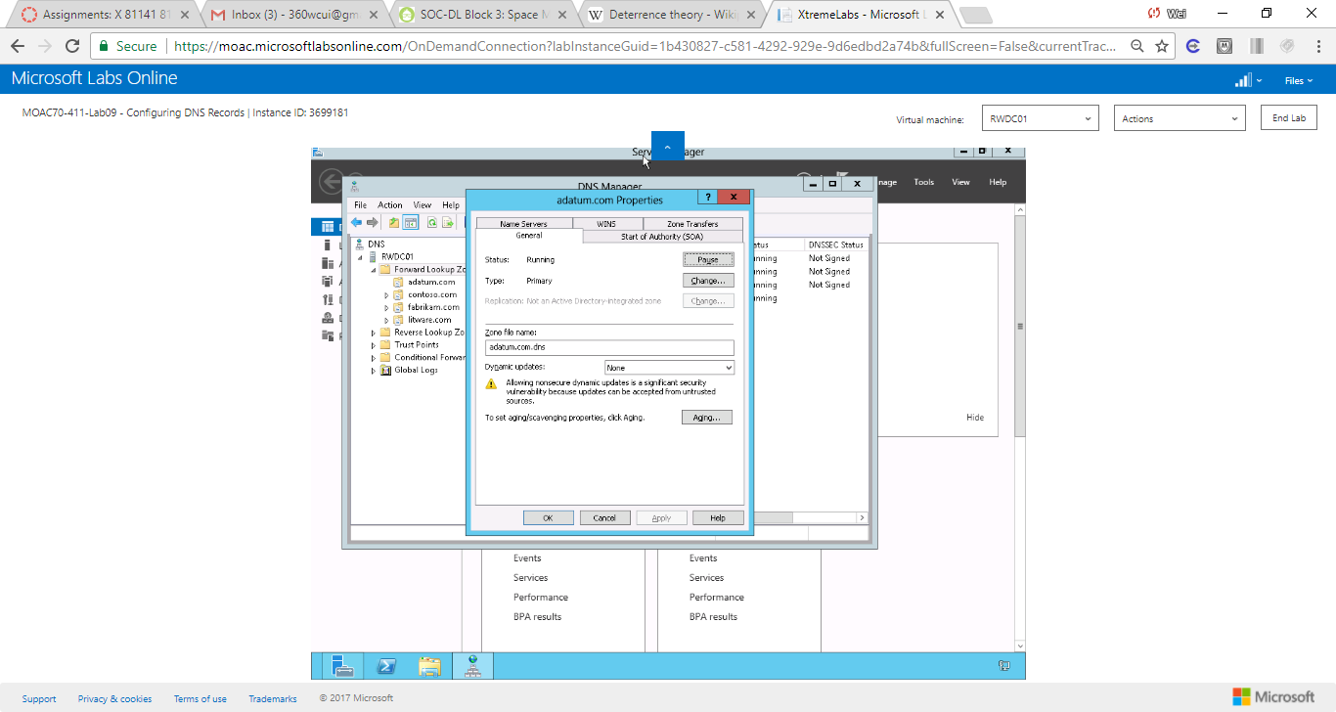

Figure Domain properties show the records can be configured

|  |  |
| --- | --- |
| Question 3 | What is the default minimum TTL for SOA records?  See figure below. |

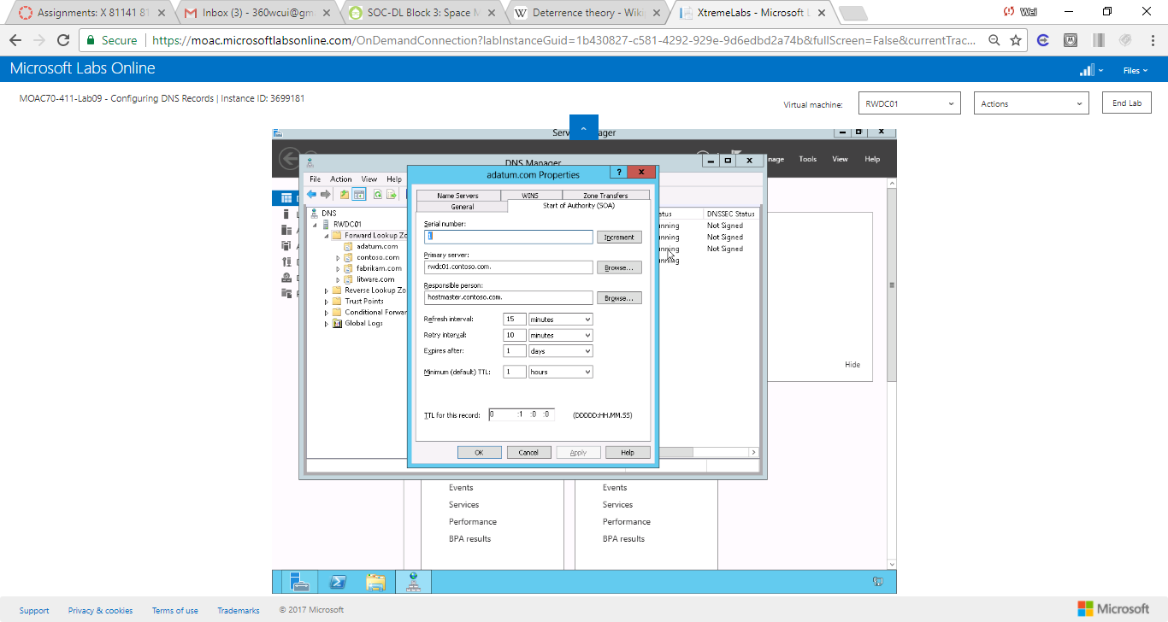

Figure Domain properties show the default minimum TTL for SOA records

**5.** Click OK to close the Properties dialog box.

**6.** Right-click adatum.com and click New Host (A or AAAA). The New Host dialog box opens as shown in Figure 9-1.

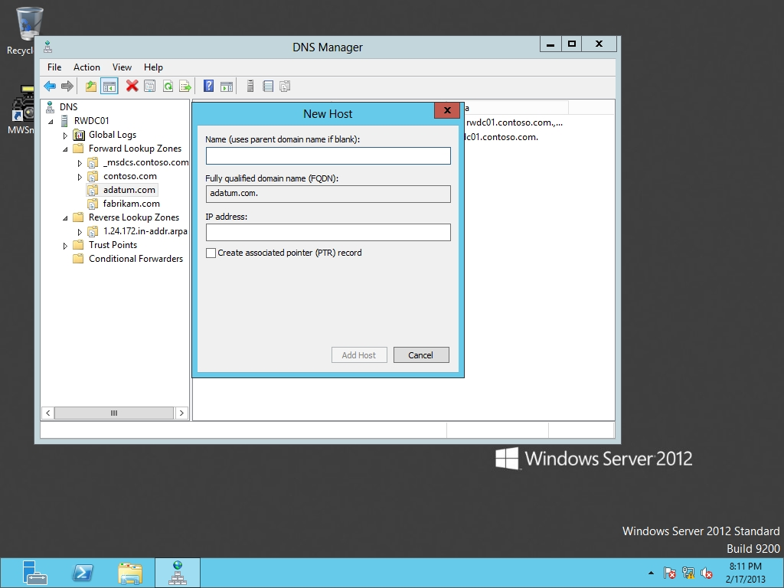

Figure 9-1

Creating a new host record

**7.** In the Name text box, type **PC1**. For the IP address text box, type **192.168.1.201**. click Add Host.

**8.** When the record has been created, click OK, then click Done.

**9.** Right-click adatum.com and click New Host (A or AAAA). In the Name text box, type **PC2**. For the IP address text box, type **192.168.1.202**. Select the *Create associated pointer (PTR) record*. Click Add Host. When the record has been created, click OK, then click Done.

**10.** Take a screen shot of the DNS Manager window by pressing Alt+Prt Scr and then paste it into your Lab09_worksheet file in the page provided by pressing Ctrl+V.

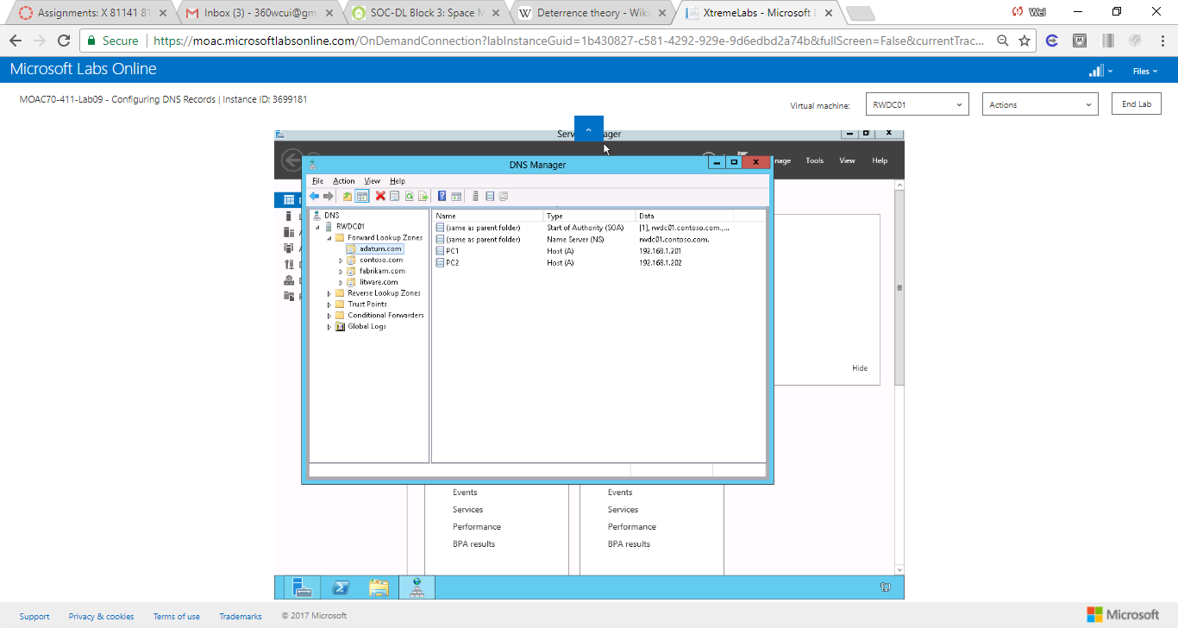

Figure The records created

**11.** Expand the Reverse Lookup Zones and click 1.168.192.in-addr.arpa zone. Notice that the 192.168.1.202 record is there, but not the 192.168.1.201. You might need to refresh the zone if 192.168.1.202 has not yet appeared. To refresh the zone, press the F5 key.

|  |  |
| --- | --- |
| Question 4 | What records are kept in the reverse-lookup zones? |

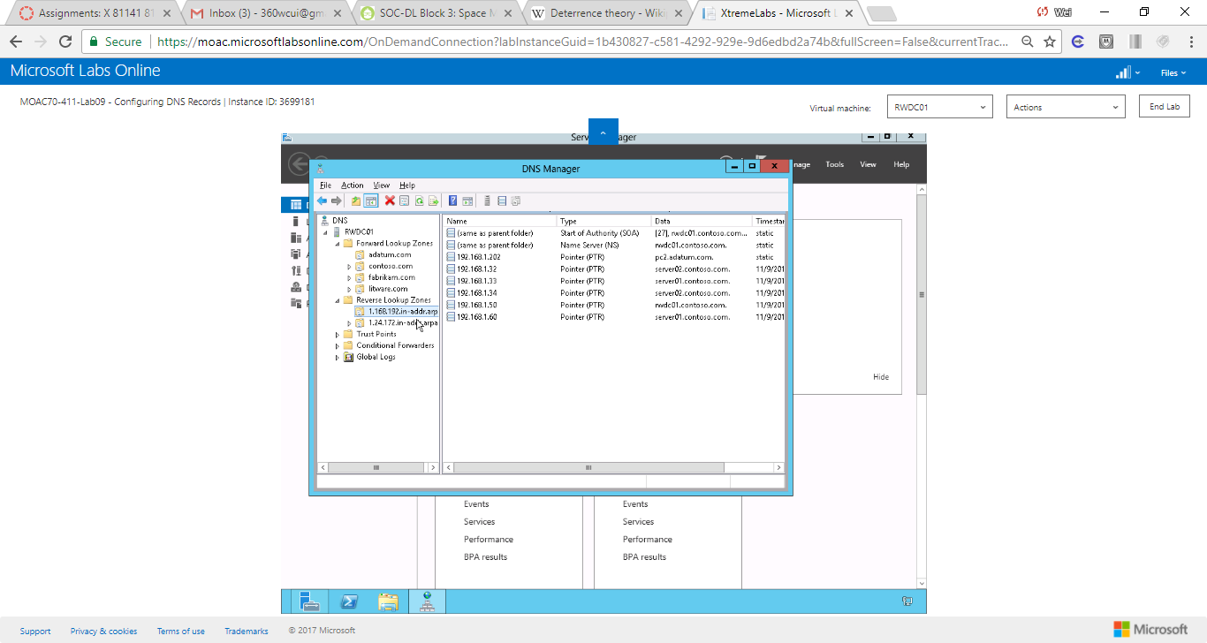

Figure Records kept in reverse look up zone

**12.** Right-click 1.168.192.in-addr.arpa and click New Pointer (PTR). The New Resource Record dialog box opens as shown in Figure 9-2.

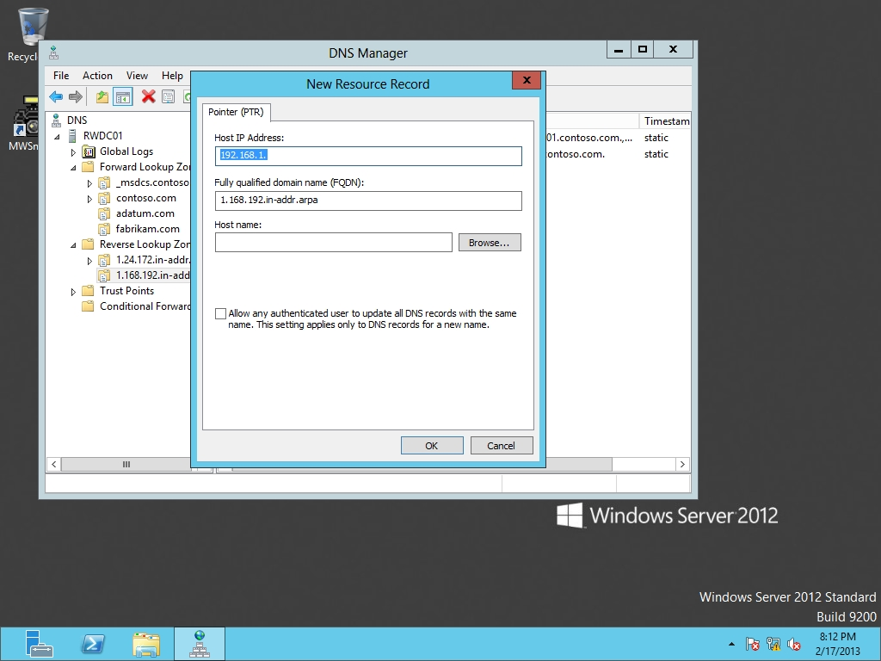

Figure 9-2

Creating a new PTR record

**13.** On the Host IP Address text box, change the text to **192.168.1.201**. In the Host name text box, type **PC1**. Click OK.

|  |  |
| --- | --- |
| Question 5 | How does the data for PC1 and PC2 differ?  Differ by their IP addresses. |

**14.** Double-click 192.168.1.201. Change the Host name from PC1 to **PC1.contoso.com.** (with a period at the end). Click OK.

|  |  |
| --- | --- |
| Question 6 | What does the period at the end signify?  it tells named that we do not want the domain added to the end of that value. If we leave the dot out, then name will add the domain to the end of the value. |

**15.** Take a screen shot of the DNS Manager window by pressing Alt+Prt Scr and then paste it into your Lab09_worksheet file in the page provided by pressing Ctrl+V.

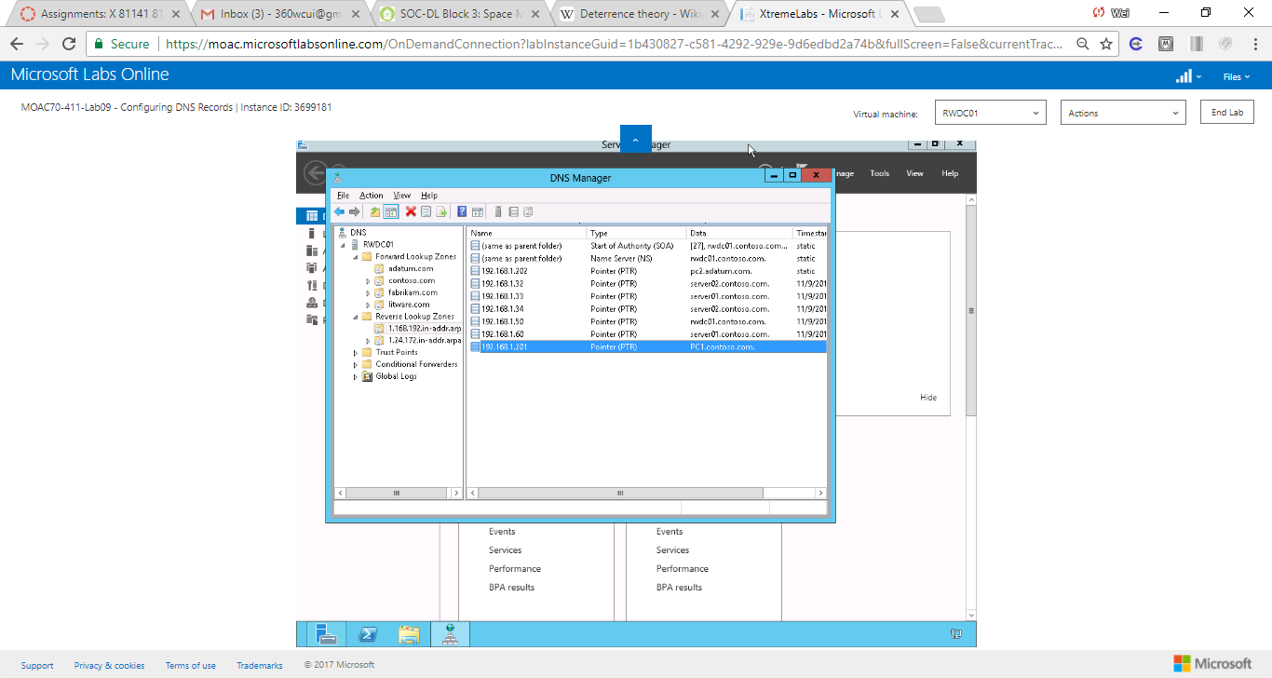

Figure a screen shot of the DNS Manager window

**16.** Right-click adatum.com and click New Host (A or AAAA). In the Name text box, type **PC3**. For the IP address text box, type **192.168.1.203**. Select theCreate associated pointer (PTR) record. Click Add Host. When the record has been created, click OK, and then click Done.

**17.** Right-click adatum.com and click New Alias (CNAME). In the Alias name, type **www**. In the Fully qualified domain name (FQDN) for target host text box, type **PC3.adatum.com**.

|  |  |
| --- | --- |
| Question 7 | What is the fully qualified domain name?  www.adatum.com |

**18.** Click OK.

**19.** Right-click the Start button and click Command Prompt (Admin). The Administrator: Command Prompt opens.

**20.** To see the name PC1 resolved to its IP address, execute the following command:

nslookup PC3.adatum.com

|  |  |
| --- | --- |
| Question 8 | What address was returned?  192.168.1.203 |

**21.** To see the IP resolution of 192.168.1.203 to its name, execute the following command:

nslookup 192.168.1.203

|  |  |
| --- | --- |
| Question 9 | What name was returned?  PC3.adatum.com |

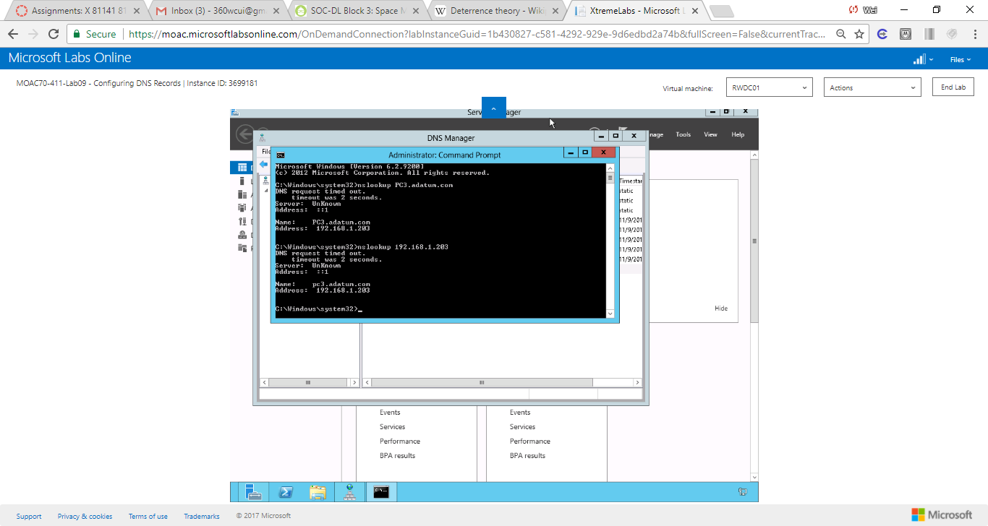

Figure Name returned from executing nslookup 192.168.1.203

**22.** To see the resolution of the alias [www.adatum.com](http://www.adatum.com) to its name and IP address, execute the following command:

nslookup www.adatum.com

|  |  |
| --- | --- |
| Question 10 | What name and IP address was returned?  See below |

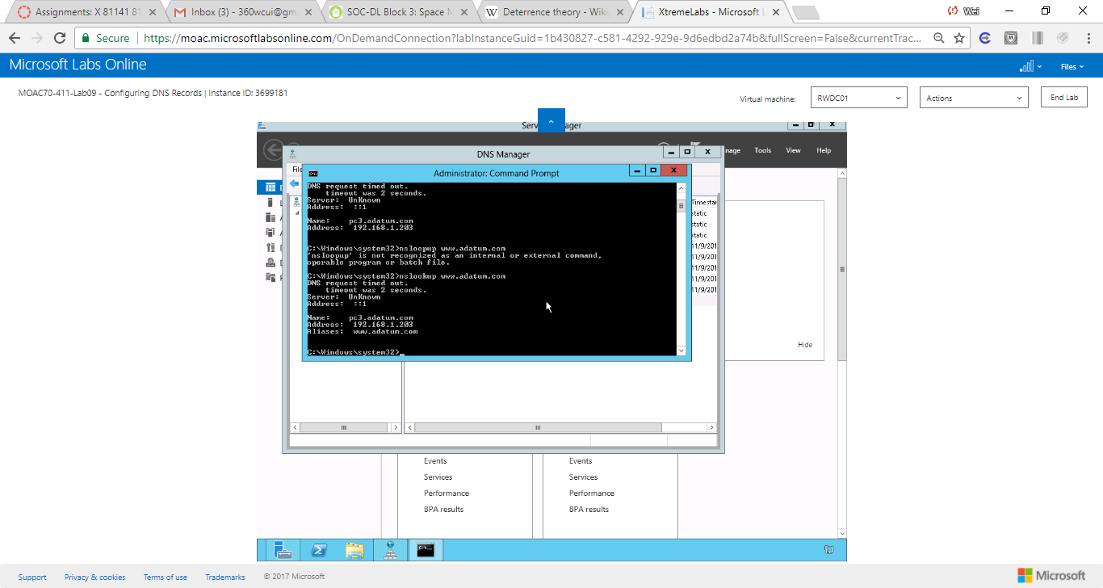

**23.** Right-click adatum.com and click New Mail Exchange (MX). In the Host or child domain text box, type **PC2**. In the Fully Qualified domain name (FQDN) of mail server, type **adatum.com**.

|  |  |
| --- | --- |
| Question 11 | What is the default Mail server priority?  10 |

**24.** Click OK.

**25.** Right-click the PC1 Host (A) record under adatum.com, and click Properties.

|  |  |
| --- | --- |
| Question 12 | What fields are displayed?  Name services, WINS, Zone Transfers, General, Start of Authority (SOA) (See figure below) |

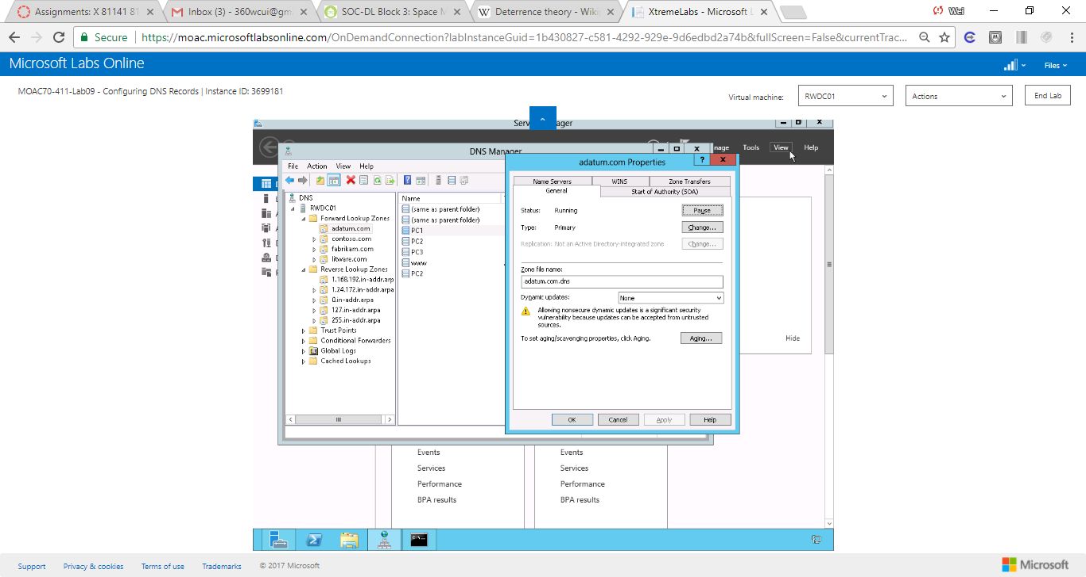

Figure Properties of PC1 Host (A) record under adatum.com

**26.** Click OK to close the Properties dialog box.

**27.** Open the View menu and click Advanced.

**28.** Right-click the PC1 Host (A) record and click Properties.

|  |  |
| --- | --- |
| Question 13 | What new field is now available with the Advanced view? |

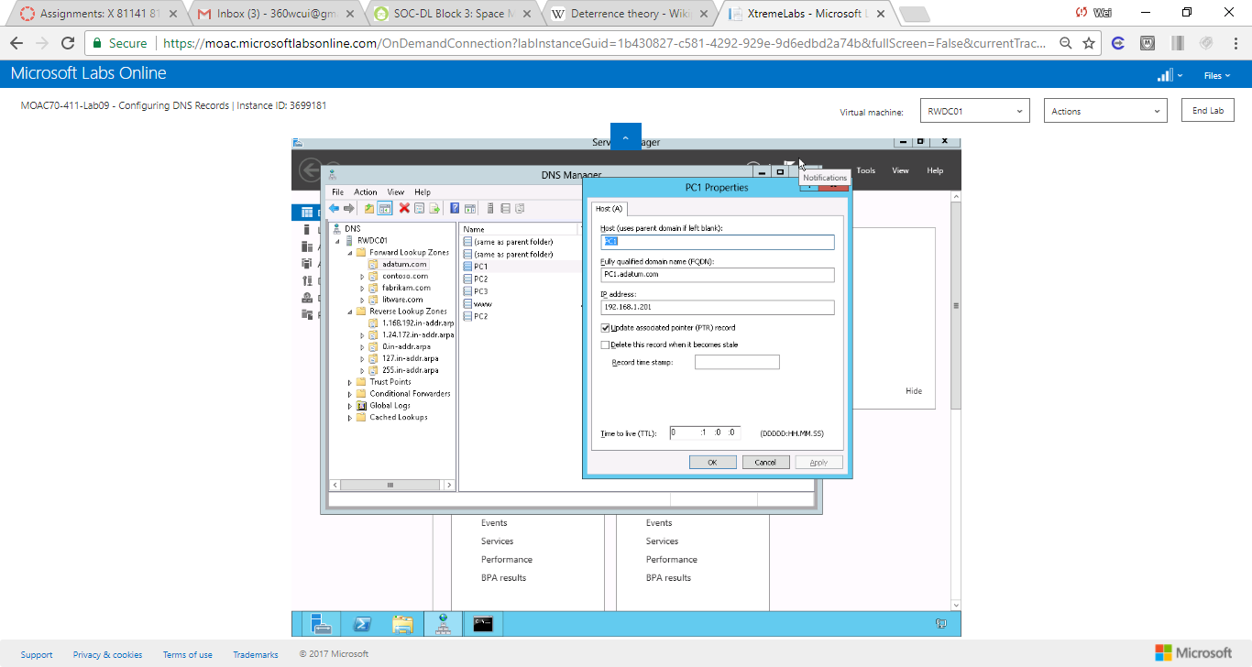

Figure Advanced properties, show Time to Live

**29.** Change the Time to live to **15** minutes. Click OK to close the Properties dialog box.

End of exercise. You can leave the windows open for the next exercise.

**Lab Summary**

In this exercise, I added some additional resource records such as CNMAE and MX. In the previous lab, I created several zones. With the exception of default resource records that were created when I created a zone, I did not add any additional recource records.